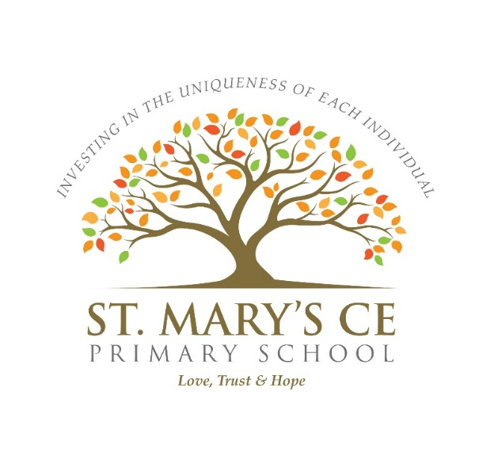

Equality Information and Objectives

Date last reviewed:
Signed by:
 | Headteacher |  | Date:
 | Chair of governors |  | Date:

Vision and Christian Ethos
“Every child matters and no child is ever left behind.”
“Let the children come to me, and do not stop them; for it is to such as these that the kingdom of God belongs.”
Luke 18:16
At St Mary’s CE Primary School, part of the Durham and Newcastle Diocesan Learning Trust (DNDLT), we believe that every individual is a unique and valued child of God. Guided by our Christian faith, we are committed to investing in the uniqueness of every individual and ensuring that all members of our school community are nurtured, respected and enabled to flourish.
Our school values of Love, Hope and Trust underpin everything we do. They shape our relationships, our curriculum, our expectations and our commitment to inclusion. We strive to be a school where every child and adult feels safe, valued and celebrated, and where no one is ever left behind.
As a Church of England school, we serve children and families of all faiths and none, welcoming diversity and celebrating the richness this brings to our community. We work closely with the DNDLT to ensure that our school remains firmly rooted in its local context while benefiting from the support, challenge and shared vision of the Trust.
Equal Opportunities Statement
This document outlines how St Mary’s CE Primary School fulfils its responsibilities under the Public Sector Equality Duty and sets out our equality objectives in line with those of the DNDLT and the Equality Act 2010.
We welcome and embrace our duties to:
- Eliminate discrimination, harassment and victimisation
- Advance equality of opportunity
- Foster good relationships between people who share a protected characteristic and those who do not
We will not discriminate against, harass or victimise any pupil, staff member, prospective pupil, parent, carer or visitor on the basis of any protected characteristic, including:
- Sex
- Age
- Race
- Disability
- Religion or belief
- Sexual orientation
- Gender reassignment
- Pregnancy or maternity
- Marriage and civil partnership
Promoting Equality and Eradicating Discrimination
At St Mary’s, we believe that recognising and valuing individuality leads to stronger outcomes for children and adults alike. We are committed to creating an inclusive environment where everyone feels confident, respected and able to be themselves.
This commitment is realised through:
- Treating all members of the school community with love, fairness and dignity
- Developing understanding of diversity, inclusion and equity, and the positive impact these have on learning and wellbeing
- Adopting an inclusive attitude rooted in our Christian values and reflected in everyday practice
- Ensuring our curriculum is inclusive, accessible and representative of the diverse world in which we live
- Encouraging compassion, kindness and open-mindedness
- Challenging prejudice, bias and discriminatory language whenever it occurs
- Ensuring equality considerations are integral to all policies, procedures and decision-making
- Promoting a culture where pupils, staff and parents feel safe to share concerns, particularly where a protected characteristic is involved
- Making and reviewing reasonable adjustments to meet the needs of pupils and staff
- Embedding a Christian ethos of inclusion in line with the Church of England’s Vision for Education and commitment to community cohesion
Curriculum, Teaching and Learning
We are committed to providing a balanced, diverse and fair curriculum that enables all pupils to thrive academically, socially, spiritually and emotionally.
Pupils at St Mary’s are encouraged to:
- Encounter ideas and perspectives that broaden their understanding
- Develop respect for difference and diversity
- Learn to engage thoughtfully with challenging or sensitive issues in an age-appropriate, respectful and inclusive way
Teaching and learning promote equality, reject discrimination and support pupils in becoming compassionate, informed and responsible members of society.
Dealing with Prejudice and Celebrating Diversity
St Mary’s CE Primary School has a zero-tolerance approach to prejudice-related incidents. Any form of discrimination, whether direct or indirect, is taken seriously and addressed swiftly and appropriately.
When incidents occur, we work in partnership with the Headteacher, Local Academy Council and the DNDLT, ensuring outcomes are fair, restorative where appropriate, and firmly rooted in our Christian values.
We expect our pupils to be:
- Understanding and respectful of others
- Celebratory of diversity
- Eager to reach their full potential
- Inclusive in their actions and attitudes
- Aware of what constitutes discriminatory behaviour
Throughout the year, we actively celebrate diversity through:
- Curriculum planning and themed learning
- Assemblies and collective worship
- Special awareness events and days
- Visitors and speakers
- Celebrating positive acts that demonstrate inclusion and kindness
Equality and Dignity in the Workplace
In line with the DNDLT Equal Opportunities Policy and the Staff Handbook, St Mary’s CE Primary School is committed to equality, dignity and fairness in the workplace.
We do not discriminate against staff on the basis of:
- Age
- Disability
- Gender reassignment
- Marriage or civil partnership
- Pregnancy or maternity
- Race
- Religion or belief
- Sex
- Sexual orientation
All staff are expected to act in accordance with equality-related policies and to model inclusive behaviour. Recruitment, professional development, disciplinary processes and, where necessary, redundancy procedures are fair, transparent and non-discriminatory.
Commitment to Ongoing Development
Working in partnership with the DNDLT, St Mary’s continues to strengthen its approach to equity, diversity, inclusion and justice (EDIJ) through:
- Staff training and professional development
- Inclusion and behaviour networks
- School development planning
- Monitoring and evaluation through Local Academy Council oversight
Closing Statement
At St Mary’s CE Primary School, prejudice is not tolerated. Inspired by our faith and guided by our values of Love, Hope and Trust, we are committed to creating a school community where everyone feels welcomed, respected and able to flourish.
Equality, inclusion and dignity are not just policies at St Mary’s – they are lived out every day in our relationships, learning and shared commitment to ensuring that every child truly matters and no one is ever left behind.

