

**English**

**Fiction – The Buried Crown, Anglo-Saxon Boy**

★ Narrative

★ Diary Entry

★ Poetry

**Spelling, Punctuation and Grammar:**

★ Active and Passive Voice

★ Commas, Dashes, Semi-colons, Colons

★ Subjunctive

**Science**

Materials and their Properties

★ Children will compare and group together everyday materials on the basis of properties.

They will know that some materials will dissolve in liquid to form a solution and describe how to recover a substance from a solution.

Children will explain that some changes result in the formation of new materials, and that this kind of change is not usually reversible

**Year 5 and 6 Curriculum Spring 2021**

**Maths**

★ Year 6: Decimals.

In this unit, children will use their knowledge and understanding of place value to help support their work with decimals. They will multiply and divide decimal numbers by whole numbers, and also by 10, 100 and 1,000. They will convert from decimals to fractions and vice versa. They will then begin using decimals in contexts such as measure.

★ Year 5: Multiplication and Division

In this unit, children will develop their understanding of multiplication and division, using numbers with up to 4 digits. They will use efficient written methods to calculate accurately. They will also be able to find and interpret remainders when dividing.

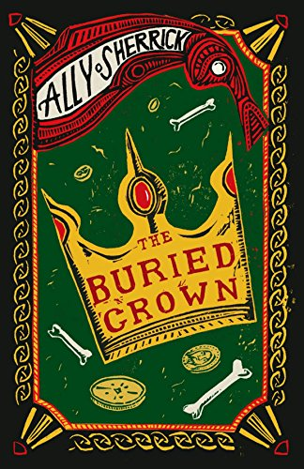

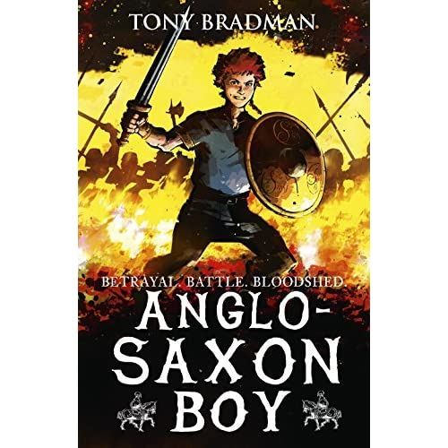

**What did the Anglo Saxons do for Britain?**

In this topic, the children will learn about the Anglo-Saxons and the impact they had on Britain. They will develop deeper understanding of invasions and settlements and will look at how religion changed over the period. They will learn about Anglo-Saxon language and locations of settlements around us and will participate in a trip to Preston Park Museum for an Anglo-Saxon workshop. In art, the children will develop their drawing, sketching and colour skills by designing Anglo-Saxon illuminated letters, leading on to creating their own graffiti looking at examples of London street art.

**PSHCE**

Keeping Myself Safe

★ Children talk about good habits. They debate dilemmas and learn about how to spot and deal with bullying. They cover issues around drugs, smoking and risks to health.

**Computing**

Computer Systems & Networks

★ This unit explores the concept of variables in programming through games in Scratch. Pupils will learn what variables are, and relate them to real-world examples of values that can be set and changed. They will create a simulation of a scoreboard, experiment with variables in an existing project, modify them, and create their own

project. Pupils will focus on design & apply their

knowledge of variables and design to improve their game.

**Music**

Music Interpretation & Description

★ Famous Musical Works and the Orchestra.

Children learn about instruments of the orchestra

and develop listening skills.

Composition/Performance

★ Children compose and perform works on a

theme.

**RE**

Salvation

★ Children will explain that the Gospels give accounts of Jesus' death and resurrection. Belief in Jesus' resurrection confirm that Jesus in the incarnate Son of God, but also that death is not the end. This belief gives Christians hope for life with God, starting now and continuing in a new life (heaven).

**PE**

Striking and Fielding Games,

★ Pupils will learn how to strike a ball with control in order to hit it where they are aiming. Pupils will also learn where to pass a ball when fielding for maximum effect.

Invasion Games

★ Pupils will refine their dribbling, passing and shooting techniques.

**French**

On Holiday

★ Children will learn the vocabulary needed to describe where they are going, where they’re

staying and how long they’re staying on holiday. This unit gives pupils the chance to develop their grammar

skills by learning about the perfect past tense.

