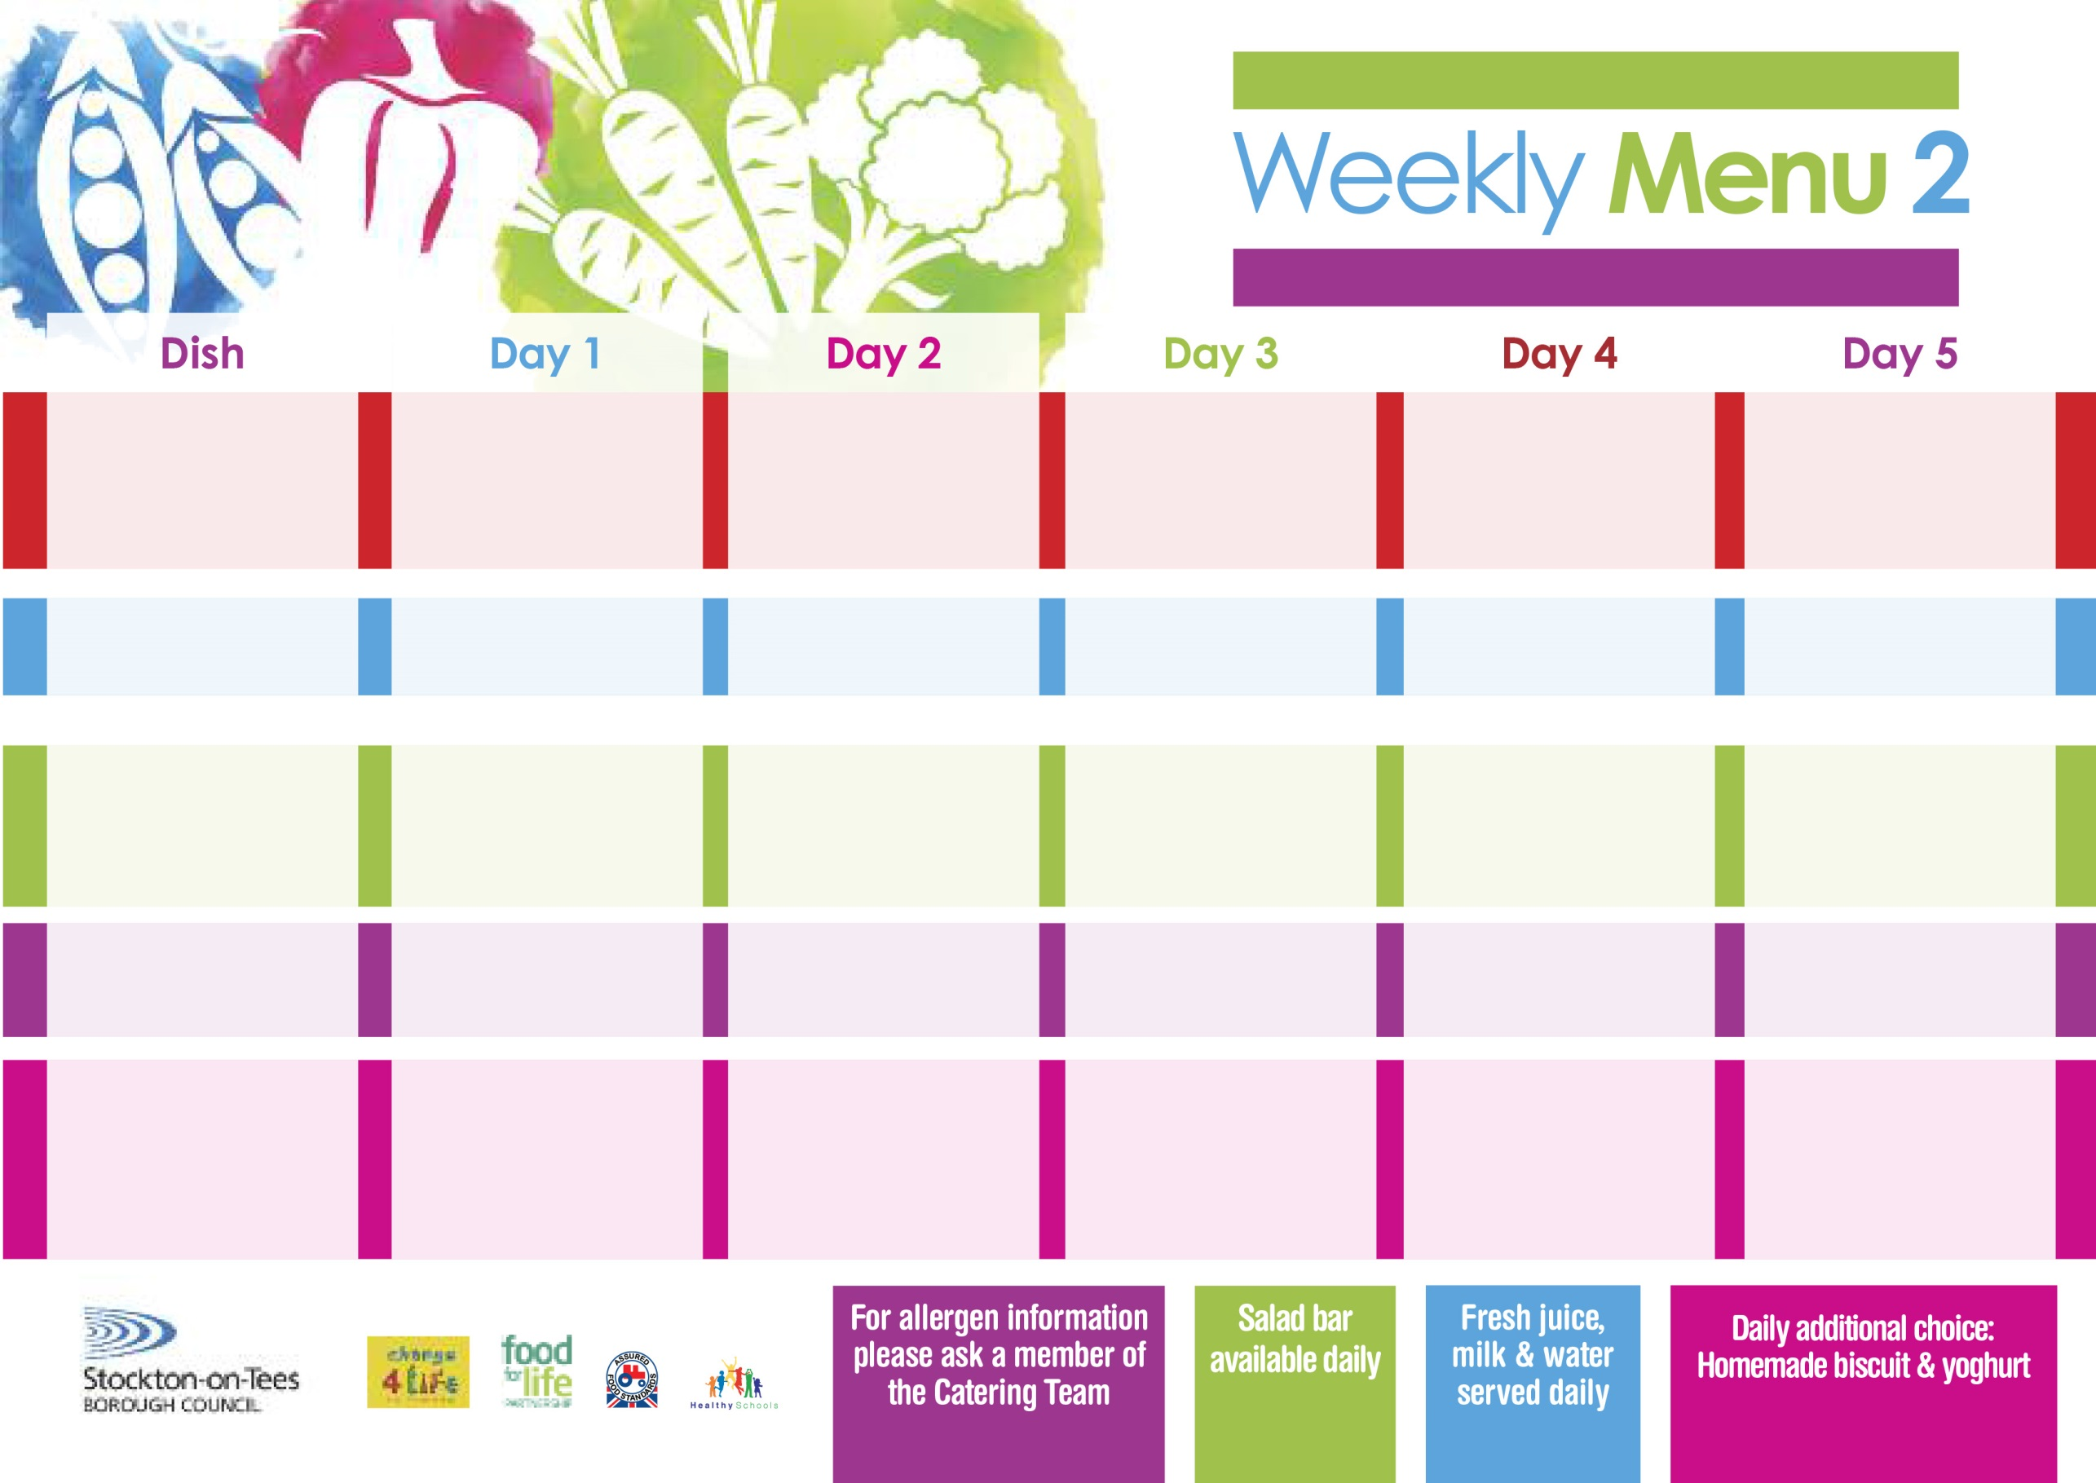

**Lasagne**

**Homemade Garlic Bread**

**Tossed Salad**

**Quorn Lasagne (V)**

**Fish Stars**

**Oven Baked Potato Wedges**

**Spaghetti Hoops**

**Egg Mayonnaise Sandwich (V)**

**Oven Baked Potato Wedges**

**Chocolate Chip Sponge**

**with Custard Sauce**

**Cold Bar**

**Fresh Fruit Salad**

**10th January, 7th February & 14th March, 2022**

**Roast Gammon served with Pineapple**

**Oven Roasted Potatoes**

**Green Beans**

**Cauliflower**

**Cheese & Tomato Pizza (V)**

**Oven Roasted Potatoes**

**Spaghetti Hoops**

**Tuna Wrap**

**Oven Roasted Potatoes**

**Chocolate Crunch**

**with Custard Sauce**

**Cold Bar**

**Fresh Fruit Platter**

**Steak Pie**

**Creamed Potatoes**

**Broccoli**

**Diced Carrots**

**Jacket Potato filled with**

**Tuna, Cheese (V) or**

**Baked Beans (V)**

**Cheese Sandwich (V)**

**Baked Potato Wedges**

**Jam Roly Poly**

**with Custard Sauce**

**Cold Bar**

**Fresh Fruit Bowl**

**Fish Goujons**

**Oven Baked Chips**

**Garden Peas**

**Baked Beans**

**Baked Cheese & Onion Roll (V)**

**Oven Baked Chips**

**Garden Peas**

**Baked Beans**

**Ham Sandwich**

**Oven Baked Chips**

**Lemon Sponge**

**with Custard Sauce**

**Cold Bar**

**Melon Boat**

**Breaded Chicken Breast**

**Oven Roasted Potatoes**

**Garden Peas**

**Sweetcorn**

**Macaroni Cheese (V)**

**Oven Roasted Potatoes**

**Garden Peas**

**Sweetcorn**

**Tuna Sandwich**

**Oven Roasted Potato**

**Cornflake Tart**

**with Custard Sauce**

**Cold Bar**

**Watermelon Slices**

**Wristband School Menu**

**Red Choice**

**Blue Choice**

**Green Choice**

**Cold Selection**

**Desserts**