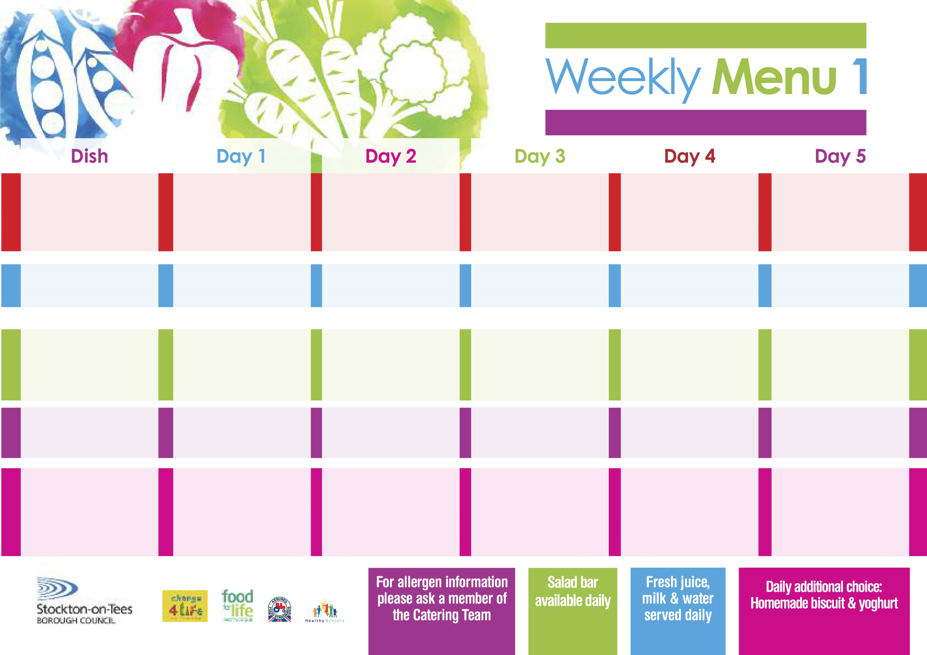

**Toad in the Hole**

**Creamed Potatoes**

**Broccoli**

**Diced Swede**

**Jacket Potato filled with Tuna, Cheese (V) or Baked Beans (V)**

**Egg Mayonnaise Sandwich (V)**

**Baked Jacket Potatoes**

**Syrup Roly Poly**

**with Custard Sauce**

**Cold Bar**

**Fresh Fruit Salad**

**3rd January, 31st January, 7th March & 4th April, 2022**

**Chicken Curry**

**Rice**

**Mixed Vegetables**

**Quorn Curry (V)**

**Fish Fillet Fingers**

**Baked Potato Wedges**

**Baked Beans**

**Cheese Wrap** **(V)**

**Baked Potato Wedges**

**Chocolate Sponge**

**with Custard Sauce**

**Cold Bar**

**Melon Boat**

**Roast Turkey served with Sage & Onion Stuffing**

**Oven Roasted Potatoes**

**Cauliflower**

**Baton Carrots**

**Salmon & Sweet Potato Fishcake**

**Oven Roasted Potatoes**

**Spaghetti Hoops**

**Ham Sandwich**

**Oven Roasted Potatoes**

**Feathered Sponge**

**with Custard Sauce**

**Cold Bar**

**Watermelon Slices**

**Wristband School Menu**

**+**

**Minced Beef & Dumplings**

**Creamed Potatoes**

**Diced Carrots**

**Garden Peas**

**Penne Pasta in**

**Tomato Sauce (V)**

**Homemade Garlic Bread**

**Diced Carrots**

**Garden Peas**

**Tuna Sandwich**

**Baked Jacket Potatoes**

**Apple Crumble**

**with Custard Sauce**

**Cold Bar**

**Fresh Fruit Bowl**

**Harry Ramsden Fish Fillet**

**Oven Baked Chips**

**Garden Peas**

**Baked Beans**

**Pizza Whirls (V)**

**Oven Baked Chips**

**Garden Peas**

**Baked Beans**

**Egg & Cress Sandwich (V)**

**Oven Baked Chips**

**Creamy Rice Pudding**

**with Jam Sauce**

**Cold Bar**

**Fresh Fruit Bowl**

**Red Choice**

**Blue Choice**

**Green Choice**

**Cold Selection**

**Desserts**