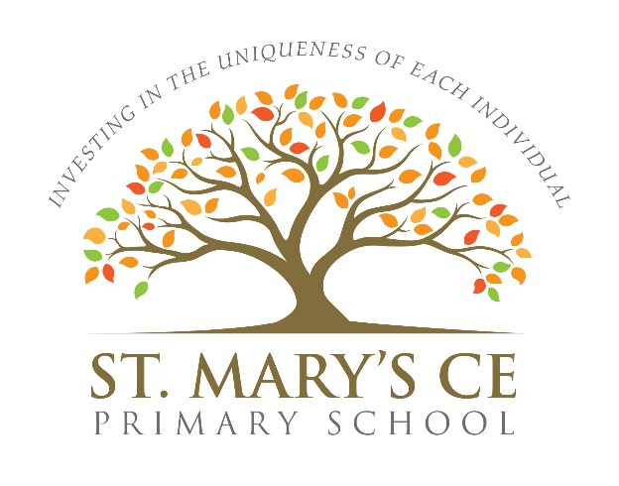

Protocol for Suspected Covid-19 Case/s in School

Version: 19th August 2020
This diagram shows how to advise individuals (children and adults) and their households if they become unwell OR if they are sent home because they have been in contact with someone who is ill.
A person with symptoms
If a person becomes unwell with a new continuous cough, or a high temperature, or has a loss of, or change in, their normal sense of taste or smell (anosmia), then they must be sent home, arrange a test and self-isolate for at least 10 days.

If a person becomes unwell with a new, continuous cough or a high temperature, or has a loss of, or change in, their normal sense of taste or smell (anosmia), then other members of their household should self-isolate for 14 days from when the symptomatic person first had symptoms.

If a person with symptoms tests positive, then other members of their household should self-isolate for 14 days from when the symptomatic person first had symptoms.
If a person with symptoms tests negative and if they feel well and no longer have symptoms similar to coronavirus (COVID-19), then they can stop self-isolating. Other members of their household can stop self-isolating.
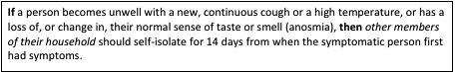

A person who is sent home because they have been in contact with someone who has tested positive
The Health Protection team will provide definitive advice on who must be sent home. A person who has been in contact with someone who has tested positive will be sent home and asked to self-isolate for 14 days.

If a person has been in contact with an individual who has tested positive and is sent home to self-isolate for 14 days, then their household does not need to self-isolate, unless the person who is self-isolating subsequently develops symptoms.

If a person who has been in contact with someone who has tested positive subsequently develops symptoms themselves within their 14-day isolation period, then they should stay at home and get a test.

If the test delivers a positive result, then they should inform their school immediately, and must isolate for at least 10 days from the onset of their symptoms.

If the test delivers a negative result, then they must remain in isolation for the remainder of the 14-day isolation period as they could still get symptoms after being tested.

If the test delivers a positive result, then their household should self-isolate for at least 14 days from when the symptomatic person first had symptoms.

If the test delivers a negative result, then their household can stop self-isolating if they do not have symptoms.

If you have any of the main symptoms of coronavirus (COVID-19), get a test as soon as possible. You must stay at home until you receive the result and then follow the instructions outlined above.

Main Symptoms
The main symptoms of coronavirus are:
- a high temperature – this means you feel hot to touch on your chest or back (you do not need to measure your temperature).
- a new, continuous cough – this means coughing a lot for more than an hour, or 3 or more coughing episodes in 24 hours (if you usually have a cough, it may be worse than usual).
- a loss or change to your sense of smell or taste – this means you've noticed you cannot smell or taste anything, or things smell or taste different to normal.
The majority of people with coronavirus have at least 1 of these symptoms.

What to do if you have symptoms:
If you have any of the main symptoms of coronavirus:
- Get a test to check if you have coronavirus as soon as possible.
- Stay at home and do not have visitors until you get your test result – only leave your home to have a test.

Anyone you live with, and anyone in your support bubble, must also stay at home until you get your result.
NHS Test and Trace
The NHS Test and Trace service will help to control the rate of reproduction (R), reduce the spread of the infection and save lives. By playing your part through the actions set out below, you will directly help to contain the virus by reducing its spread. This means that, thanks to your efforts, the Government will be able to go as far as it is safe to go in easing lockdown measures.
You can help in the following ways:
- if you develop symptoms, you must continue to follow the rules to self-isolate with other members of your household and get a test to find out if you have coronavirus.
- if you test positive for coronavirus, you must share information promptly about your recent contacts through the NHS Test and Trace service to help them alert other people who may need to self-isolate.
- if you have had close recent contact with someone who has coronavirus, you must self-isolate if the NHS Test and Trace service advises you to do so.

Definitions
‘Self-isolation if you have symptoms’ means you and all household members must remain at home. Do not go outside your home for any reason i.e. to work, school, or public areas, and do not use public transport or taxis. The guidance for households with possible coronavirus infection page has more information on self-isolation.
‘Contact’ means a person who has been in close contact with someone who has tested positive for coronavirus and who may or may not live with them.

Imposed Government Lockdown

In the event of a local lockdown, visit your local authority’s website for further guidance and follow the public health guidance for your local area.

Clinically Extremely Vulnerable Person/s

Introduction

If you’re clinically extremely vulnerable you were advised to take extra precautions during the peak of the pandemic in England. This is known as ‘shielding’.
The Government is advising that you do not need to shield at the moment. This is because the rates of transmission of coronavirus (COVID-19) in the community have fallen significantly.

There is specific guidance on what will happen if there is a local lockdown in your area.

This guidance is government advice and it’s your personal choice whether to follow it.

What has changed

The guidance for the clinically extremely vulnerable is that shielding has been paused.

This means:
- you do not need to follow previous shielding advice
- you can go to work as long as the workplace is Covid-secure, but should carry on working from home wherever possible
- clinically extremely vulnerable children should attend education settings in line with the wider guidance on reopening of schools and guidance for full opening: special schools and other specialist settings
- you can go outside as much as you like but you should still try to keep your overall social interactions low
- you can visit businesses, such as supermarkets, pubs and shops, while keeping 2 metres away from others wherever possible or 1 metre, plus other precautions
- you should continue to wash your hands carefully and more frequently than usual and that you maintain thorough cleaning of frequently touched areas in your home and/or workspace
- you will no longer receive free food parcels, medicine deliveries and basic care from the National Shielding Service
- For practical tips on staying safe, see the guidance on how to stay safe outside your home.
- You will still be able to get:
  - local volunteer support by contacting your local authority
  - prescriptions, essential items and food you buy delivered by NHS Volunteer Responders
  - priority slots for supermarket deliveries (if you previously registered for free food parcels)

If transmission of COVID-19 increases

You could be advised to shield again if the situation changes and there is an increase in the transmission of COVID-19 in the community.
Your name will be kept securely on the shielded patient list by NHS Digital. They will write to you if the advice changes. Any national changes will be reflected in this guidance.

In the event of a local lockdown visit your local authority’s website for further guidance.

If you’re clinically extremely vulnerable, you are advised not to enter any area where shielding advice is in place.

Definition of ‘clinically extremely vulnerable’

Expert doctors in England have identified specific medical conditions that, based on what we know about the virus so far, place some people at greatest risk of severe illness from COVID-19. Disease severity, medical history or treatment levels will also affect who is in this group.

Clinically extremely vulnerable people may include:

- solid organ transplant recipients
- people with specific cancers:
  - people with cancer who are undergoing active chemotherapy
  - people with lung cancer who are undergoing radical radiotherapy
  - people with cancers of the blood or bone marrow such as leukaemia, lymphoma or myeloma who are at any stage of treatment
  - people having immunotherapy or other continuing antibody treatments for cancer
  - people having other targeted cancer treatments that can affect the immune system, such as protein kinase inhibitors or PARP inhibitors
  - people who have had bone marrow or stem cell transplants in the last 6 months or who are still taking immunosuppression drugs
- people with severe respiratory conditions including all cystic fibrosis, severe asthma and severe chronic obstructive pulmonary disease (COPD)
- people with rare diseases that significantly increase the risk of infections (such as severe combined immunodeficiency (SCID), homozygous sickle cell)
- people on immunosuppression therapies sufficient to significantly increase risk of infection
- women who are pregnant with significant heart disease, congenital or acquired
- other people who have also been classed as clinically extremely vulnerable, based on clinical judgement and an assessment of their needs. GPs and hospital clinicians have been provided with guidance to support these decisions
- You can find out more about who is classed as clinically extremely vulnerable on the NHS Digital website.

If you do not fall into any of these categories, but you are still concerned, you should discuss your concerns with your GP or hospital clinician.

Work and employment

You can go to work as long as the workplace is Covid-secure, but should carry on working from home wherever possible.
You may be able to take up an alternative role or change your working patterns temporarily.

Clinically Extremely Vulnerable Person/s - Flow Chart

Employee has identified as Clinically Extremely Vulnerable under latest Government Guidance

Head Teacher/Line Manager will have a meeting to discuss the employee's concerns

The Head Teacher/Line Manager will liaise with Avec HR and H&S

Complete/Review Risk Assessment with the support of AVEC H&S ensuring all reasonable adjustments have been implemented. Ensure this is shared with and agreed by the employee prior to returning to work.

